The Excel file appears to be a **sales and operations dataset for a collection of shops**, likely in the retail or e-commerce sector, with two distinct tables shown in the images. The documentation below describes the structure, data, and observed functions.

**Excel File Documentation**

This file contains sales and operational data for various shops, detailing their mode of operation, geographical presence, performance metrics, and staffing.

**Table 1: Main Shop Data (Reference Table)**

This table, shown in the first image, is structured in a standard columnar format. It contains the primary records for the shops and appears to be the main reference for lookups.

| Column Header | Description | Data Type | Notes |
| --- | --- | --- | --- |
| **shop_name** | The name of the retail outlet or e-commerce service. | Text | Used as the lookup value (key). |
| **address** | The primary physical or service address/location of the shop. | Text |  |
| **mode** | Whether the shop operates **offline** (physical store) or **online** (e-commerce/delivery). | Text |  |
| **outlets with v lookup** | The number of operational physical/service outlets. | Number | **Contains a VLOOKUP formula** (see Formula Analysis). |
| **customer_count** | A metric for the number of customers (e.g., daily, monthly, or total unique). | Number |  |
| **sales with v lookup** | The total sales amount for the shop. | Number | **Contains a VLOOKUP formula** (see Formula Analysis). |
| **employee** | The number of employees associated with the shop. | Number |  |

**Observed Data Points (Partial)**

| shop_name | mode | customer_count | sales | employee |
| --- | --- | --- | --- | --- |
| **dmart** | offline | *(Blank)* | 100000 | 700 |
| **vishal mega mart** | offline | 1000 | 10000 | 100 |
| **reliance mart** | offline | 7000 | 200000 | 1000 |
| **swiggy instamart** | online | 15000 | 200000 | 5000 |
| **big basket** | online | 12000 | 150000 | 7000 |
| **dukan_wala** | offline | 2000 | 50000 | 20 |

**Table 2: Lookup and Transformation Table (Secondary Data)**

The second image shows the main table (Table 1) along with a second, smaller table at the bottom. This second table appears to be a **transformed or filtered subset** of the main data, with columns rearranged.

| Column Header | Description | Data Type |
| --- | --- | --- |
| **shop_name** | Shop name. | Text |
| **mode** | Operating mode. | Text |
| **employee** | Number of employees. | Number |
| **outlets** | Number of outlets. | Number |
| **sales** | Sales amount. | Number |
| **address** | Address/location. | Text |
| **customer_count** | Customer count. | Number |

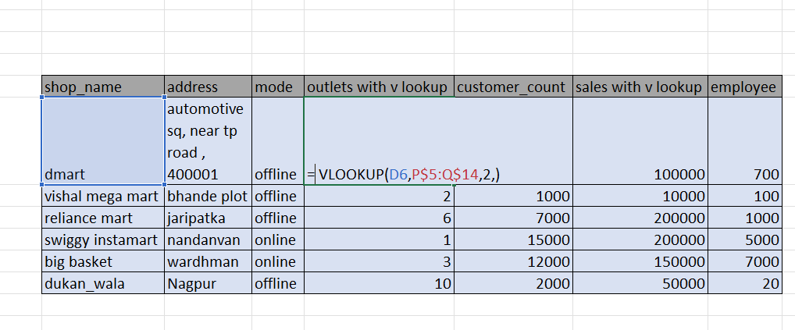**Observed Data Points**

| shop_name | mode | employee | outlets | sales | address | customer_count |
| --- | --- | --- | --- | --- | --- | --- |
| **dmart** | offline | 700 | 5 | 100000 | automotive sq, near tp road, 400001 | 5000 |
| **swiggy instamart** | online | 5000 | 1 | 10000 | nandanvan | 15000 |

**What's Happening in the Excel File (Formula Analysis)**

The file is being used to demonstrate and test **lookup functions** in Excel, specifically **VLOOKUP** (Vertical Lookup) and **HLOOKUP** (Horizontal Lookup).

**1. VLOOKUP Demonstration**

In the first image, a **VLOOKUP** function is entered in the cell for the number of outlets for 'dmart' (under the column **outlets with v lookup**).

The formula is:

=VLOOKUP(D6,P$5:Q$14,2,)

* **Lookup Value (D6):** The function is searching for the value in cell D6 (which is likely the shop_name for the *row above* the visible data, or possibly an error in the screenshot's row reference, but it should typically look for the shop name in that row, like 'dmart').
* **Table Array (P$5:Q$14):** The data range being searched. This suggests there is a **separate, hidden table** located in columns **P and Q** that contains two columns of data.
* **Column Index (2):** It is returning the value from the **second column** of the lookup table (P$5:Q$14).
* **Range Lookup (Blank):** A blank fourth argument defaults to **TRUE** (or approximate match), which is generally *not* recommended for looking up names or IDs.

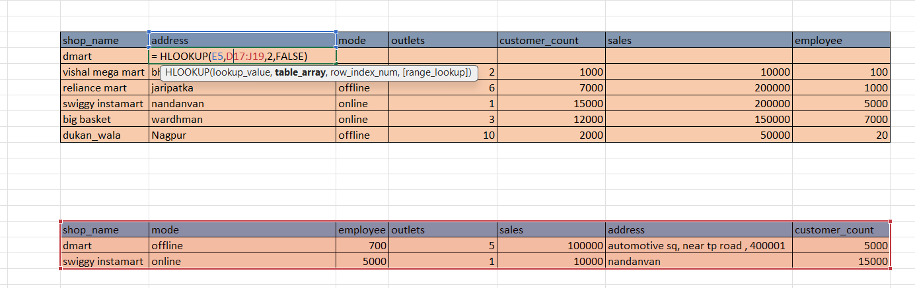**What it does:** It looks up a shop's identifier in a separate table (P5:Q14) and pulls in the value from the second column of that table, populating the **Outlets** and **Sales** columns in the main table.

**2. HLOOKUP Demonstration**

In the second image, an **HLOOKUP** function is entered in the cell for the number of outlets for 'dmart' (under the column **outlets**).

The formula is:

=HLOOKUP(E5,D7:J19,2,FALSE)

* **Lookup Value (E5):** The function is searching for the value in cell E5. Based on the screenshot, this cell seems to contain the **Address** of 'dmart' (e.g., 'automotive sq, near tp road, 400001').
* **Table Array (D7:J19):** The data range being searched, which includes the entire **Main Shop Data** table (Table 1), starting from the row containing 'vishal mega mart'.
* **Row Index (2):** It is returning the value from the **second row** of the lookup array (D7:J19).
* **Range Lookup (FALSE):** This ensures an **exact match** is found for the address.

**What it does:** It looks up the 'dmart' address in the first row of the table array and returns the value from the second row corresponding to that address. However, **HLOOKUP** is typically used when the header row is the lookup key. Using the Address as the key to return the value from the row below it (which is 'vishal mega mart's' data) is a non-standard and likely **incorrect or flawed implementation** of **HLOOKUP** for this dataset.

**Summary**

The user is working with a shop performance dataset and is practicing how to use **VLOOKUP** to integrate data from another source and **HLOOKUP** to retrieve data horizontally. The **VLOOKUP** structure appears correct (assuming the external table exists), but the **HLOOKUP** example is logically unsound for retrieving the correct data for 'dmart'.